CALL LOGIN PARTNERS

How to Create a Directory in Linux via mkdir Command

The
mkdir
directories.
mkdir
command in Linux/Unix is a command-line utility that allows users to create new stands for "make directory."

With mkdir, you can also set permissions, create multiple directories at once, and much more.

mkdir Command Syntax in Linux

The command has the following syntax:
mkdir
mkdir [options] dir_name
Copy
The [options] section is optional and modifies mkdir's behavior. The available options are listed in the section below.

The dir_name is the name or names of the directories you want to create. You can specify multiple directory names separated by spaces.


Note: Use the cd command to navigate to the directory where you want to
create a sub-directory. You can also use the direct path. Additionally, use ls to list the directories in the current location.

Example 1: How to Create New Directory in Linux
To create a directory using the terminal, pass the desired directory name to the command.
mkdir

In this example, we create a directory named Linux. Commands in Linux and options are case sensitive, so pay attention to capitalization:
mkdir Linux
Copy
If the operation is successful, the terminal returns an empty line. To verify the directory's creation, use the ls command:
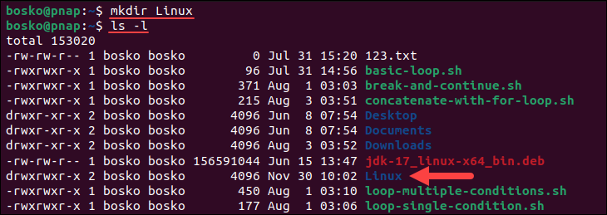
ls -l
Copy


Note: To create a hidden directory, follow our guide on how to hide files in Linux.

Example 2: Create Directory in Specific Location
To create a directory or directories in a specific location other than your current working directory, specify the full directory path. For example:
mkdir /tmp/example
Copy
The command creates a directory example in the specified location. Let's switch to that directory and check:
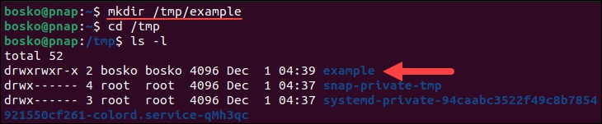
cd /tmp
ls -l
Copy

Listing the contents of the directory shows that the directory was created.

Example 3: How to Create Multiple Directories
While it is possible to create directories one by one with mkdir, it can be time-consuming when
mkdir

you need to create more than a few. To avoid that, run a single directory names separated by a space.
For example:
mkdir dir1 dir2 dir3
Copy

The command above creates the three specified directories.
command and list the

However, you can also use
mkdir
with curly brackets
to create multiple directories. For

example, to create several directories, list them within curly brackets, without spaces:
{}

mkdir {test1,test2,test3}
Copy
You can also create a batch of directories starting with the same pattern. Prepend the curly brackets with the pattern and use the brackets to specify the number of directories. For example:
mkdir dir{1..15}
Copy
The command above creates 15 directories, from dir1 to dir15.
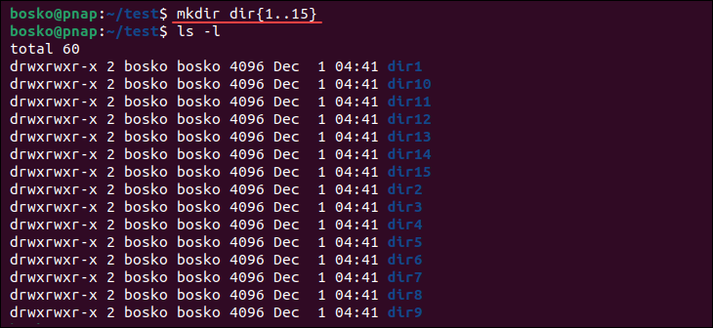

Do not add any spaces in the curly brackets for the directory names. If you do, the names in question will include the extra characters.

Example 4: How to Use Environment Variables in Directory Names
also allows you to use environment variables in directory names. In the following example, we create a directory with the current user being the directory name:
mkdir
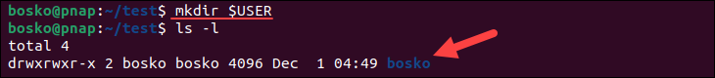
mkdir $USER
Copy

Listing the directory contents shows that the directory was created using the current user's name.

Example 5: How to Make Parent Directories

Building a structure with multiple subdirectories using
mkdir
requires adding the
option.

This ensures that adds any missing parent directories in the process.
-p
mkdir

For example, if you want to create dirtest2 in dirtest1 inside the Linux directory (i.e.,
Linux/dirtest1/dirtest2), run the following command:
ls -R
mkdir –p Linux/dirtest1/dirtest2
Copy
Use to show the recursive directory tree.
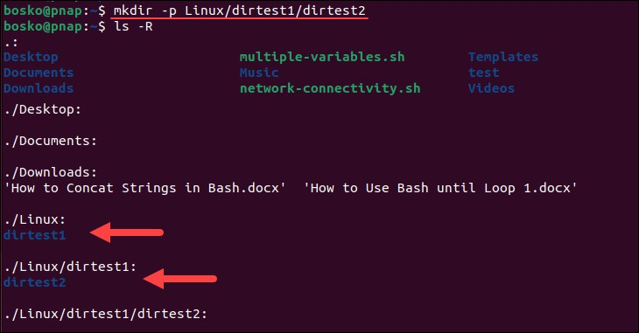

Without the not exist.
-p
option, the terminal returns an error if one of the directories in the string does

Example 6: How to Set Permissions When Making a Directory
rwx

The
mkdir
by default.
777
command gives
(read, write, and execute) permissions for the current user only

To add all the permissions for all users, specify the directory.
-m
option with the user
when creating a

Run the following command to create a directory DirM with rwx permissions:
mkdir –m777 DirM
Copy

To list all directories and show the permissions sets, run:
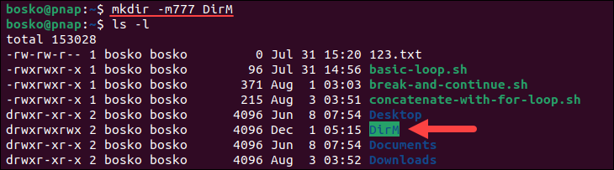
ls -l
Copy

Example 7: How to Verify Directories
When executing commands, there is no feedback for successful operations. To see the
-v
mkdir
mkdir

details of the
process, append the
option to the command.

Let’s create a Details directory and print the operation status:

By getting the feedback from the process, you do not have to run the directory was created.
ls
command to verify the


Note: Learn to fully manage directories by learning to move a directory in a system running a Linux distribution.


Conclusion

This guide showed how to use the Linux command to create new directories via the
mkdir
command line. You can also use the command to set the permissions for the new directory and ensure the right users have read, write, and execute rights.
Next, check out our essential Linux commands tutorial and download a handy PDF cheat sheet.

Was this article helpful? Yes No

Contents
- mkdir Command Syntax in Linux
- mkdir Linux Command Options
- mkdir Linux Examples
  - Example 1: How to Create New Directory in Linux
  - Example 2: Create Directory in Specific Location
  - Example 3: How to Create Multiple Directories
  - Example 4: How to Use Environment Variables in Directory Names
  - Example 5: How to Make Parent Directories
  - Example 6: How to Set Permissions When Making a Directory
  - Example 7: How to Verify Directories

Subscribe to our newsletter

SUBSCRIBE

Next you should read



SysAdmin

How to Add User to a Group in Linux


Networking, Security, Web Servers

Nmap Commands - 17 Basic Commands for Linux Network



SysAdmin, Web Servers

How to List Users in Linux, List all Users Command


SysAdmin

How To Use grep Command In Linux/UNIX

CONTACT US COLOCATION

Get a Quote
Support (1-855-330-1509)
Sales (1-877-588-5918)






Phoenix Ashburn
Amsterdam Atlanta
Belgrade Singapore
Shipping Instructions

RECENT POSTS
How to Install asdf to Manage Dev Environments MySQL INSTR() Function Explained
400 Bad Request Error: Causes and Troubleshooting Steps
Python for Loop: Syntax, Usage, Examples

SERVERS
Bare Metal Cloud Dedicated Servers Database Servers
Virtualization Servers
High Performance Computing (HPC) Servers Dedicated Streaming Servers
Dedicated Game Servers Dedicated Storage Servers SQL Server Hosting
Dedicated Servers in Amsterdam Cloud Servers in Europe
Big Memory Infrastructure

BUY NOW BMC PORTAL
127.0.0.1:62893 Explained: Meaning, Usage, Troubleshooting

CLOUD SERVICES
Data Security Cloud Managed Private Cloud Object Storage

SOLUTIONS
Disaster Recovery Web Hosting Reseller SaaS Hosting

COMPLIANCE
HIPAA Ready Hosting PCI Compliant Hosting Privacy Center
Do not sell or share my personal information

NEEDS COMPANY

Disaster Recovery Solutions High Availability Solutions
About phoenixNAP IaaS Solutions

Cloud Evaluation

INDUSTRIES
Web Hosting Providers Legal
MSPs & VARs Media Hosting Online Gaming
SaaS Hosting Solutions
Ecommerce Hosting Solutions
Customer Experience Platform
Schedule Virtual Tour Open Source Community Resource Library
Press Events Careers

PROMOTIONS

Cont | L | Privacy | Terms | D | G | Site | B | Reso | Knowled | IT | Git | RFP
act | e | Policy | of Use | M | D | ma | l | urce | ge Base | Gloss | Hu | Templa
Us | g |  |  | C | P | p | o | s |  | ary | b | te
 | al |  |  | A | R |  | g

© 2025 phoenixNAP | Global IT Services. All Rights Reserved.

